**Lab 7**

2.Write a code to create/populate a database named “Employees_Departments”. Take a screenshot for the code.

**create database Employees_Departments;**

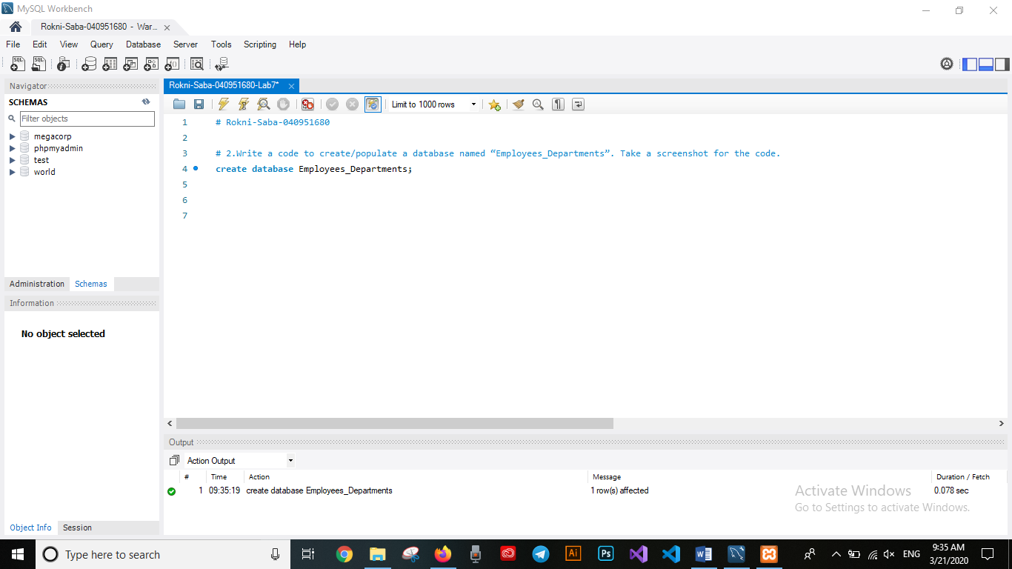

3.Write a code to use the created database in coming codes. Take a screenshot for the code.

**use Employees_Departments;**

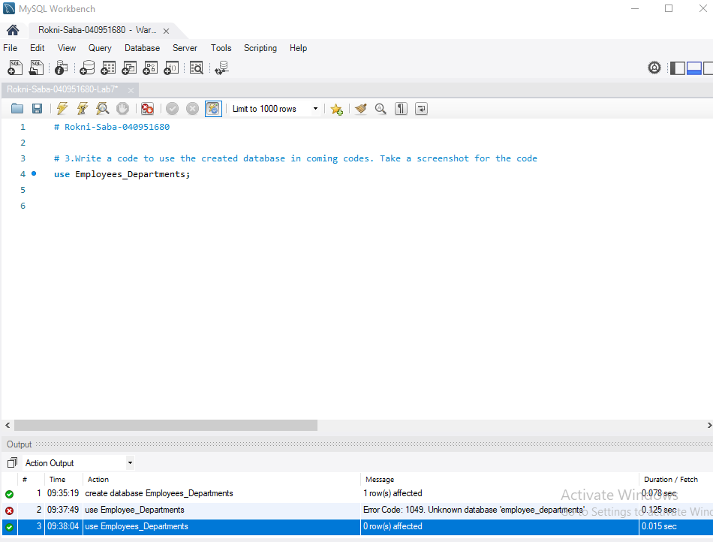

4.Create the tables of the design below. For each table, write the code to create it and take a screenshot for the code.

4-1>>

**CREATE TABLE Employee (E_ID INT4 Primary key, E_Name smallint, E_Specialization INT4);**

**Create table Department (Dep_ID int4 Primary key, Dep_Name text, Dep_Manager text);**

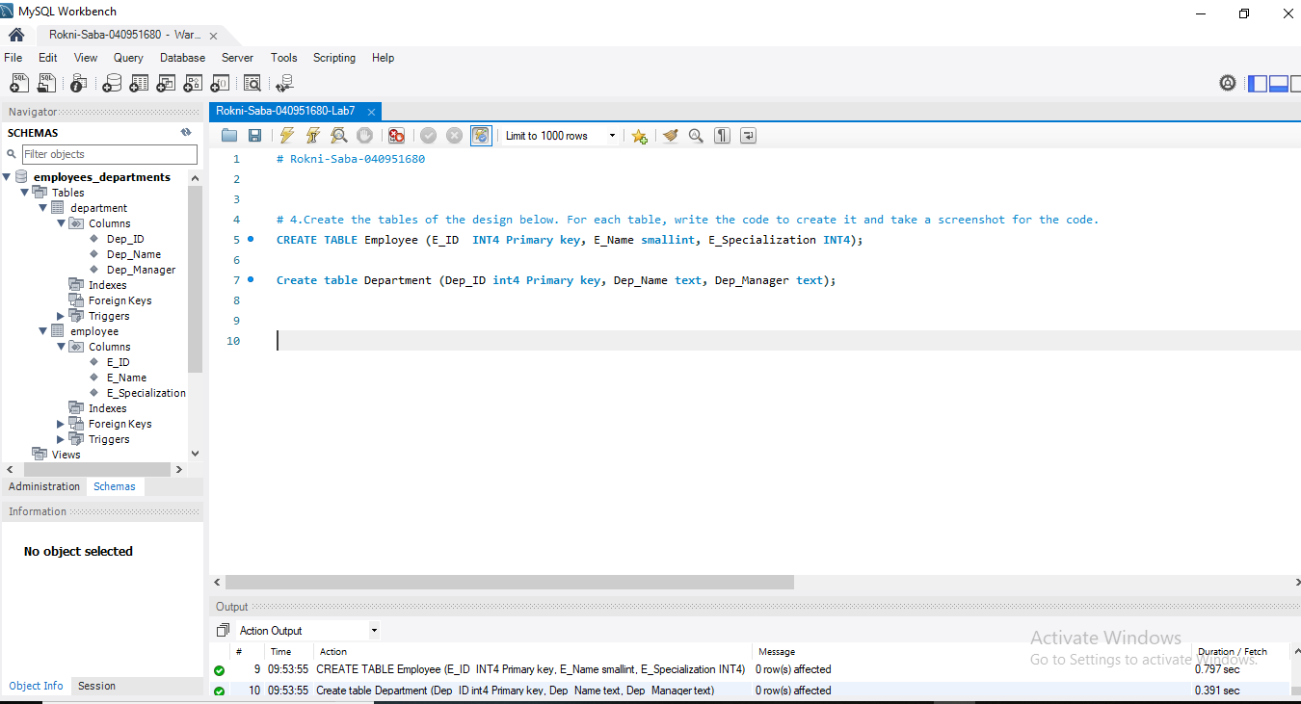

4-2>>

**CREATE TABLE Employee_Department (E_ID INT4 NOT NULL, Dep_ID INT4 NOT NULL, FOREIGN KEY (E_ID) REFERENCES Employee (E_ID), FOREIGN KEY (Dep_ID) REFERENCES Department (Dep_ID), PRIMARY KEY (E_ID , Dep_ID) );**

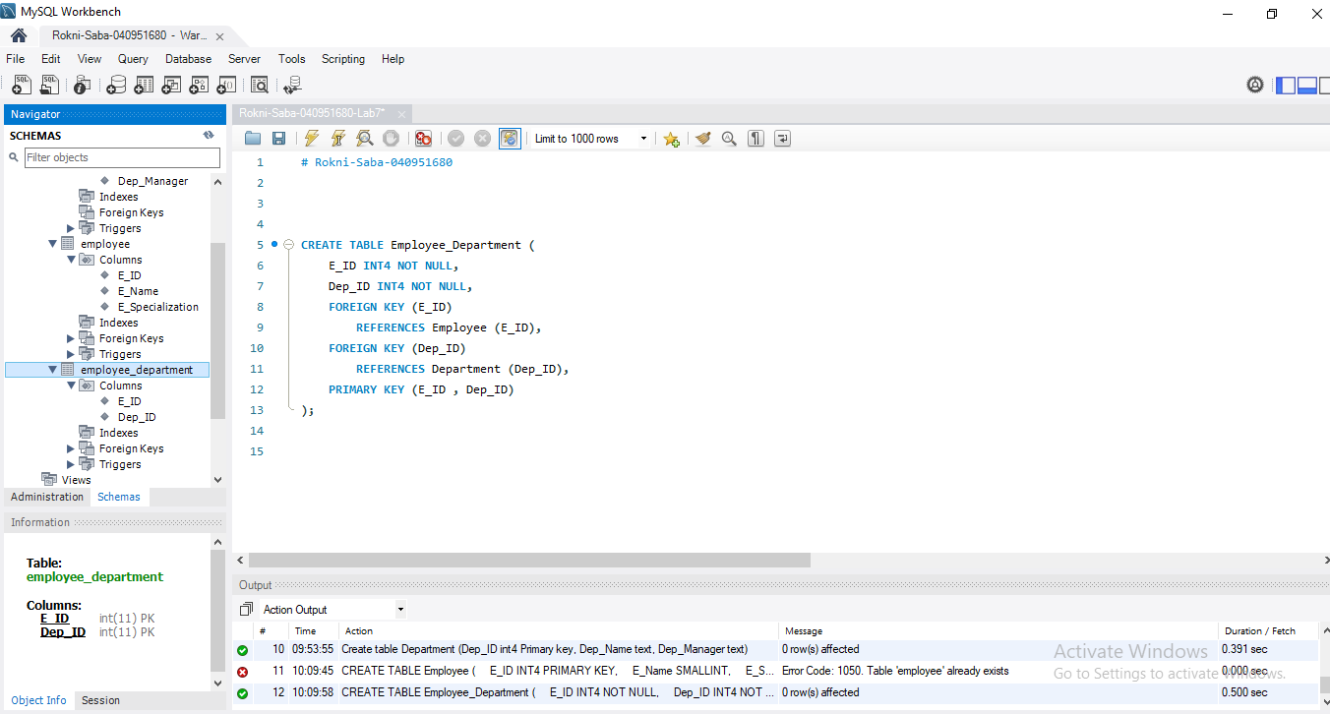

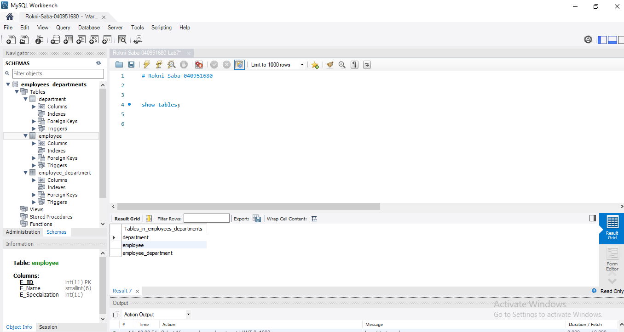

5.Insert three records in each table (you can providethe data from you). For each table, write the code to insert the data and take a screenshot for the code.

5.1>>

**INSERT INTO Employee ( E_ID , E_Name , E_Specialization) values (11,10,4420) ,(22,20,5510) , (33,30,6630);**

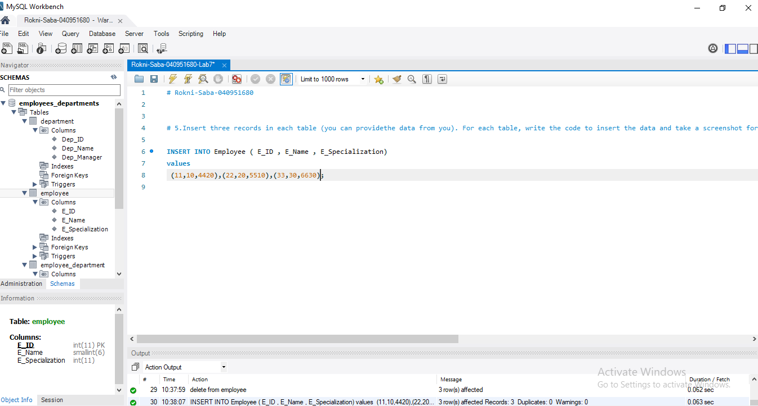

5.2 >>

**INSERT INTO Department (Dep_ID , Dep_Name , Dep_Manager ) values (101,'IT Department','Dave') , (102,'HR Department','Rojer'),(103,'Financial Department','Sasy');**

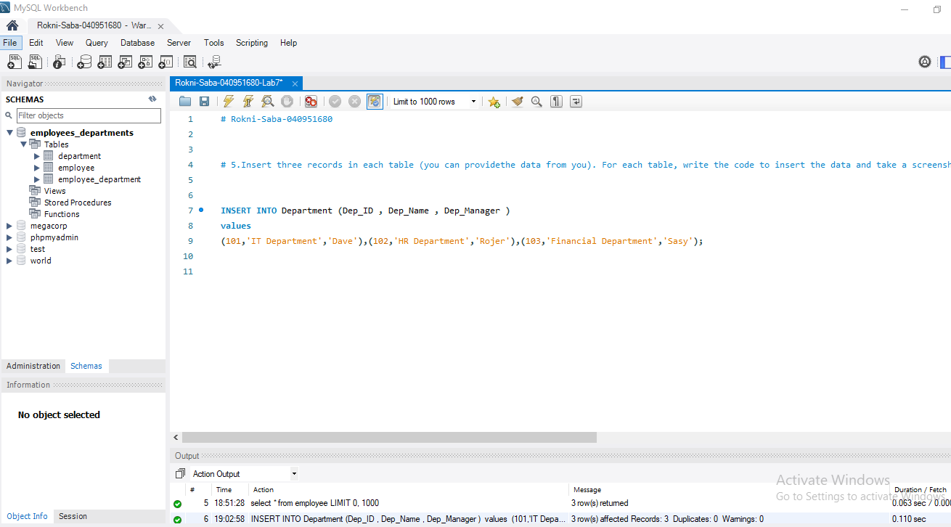

5.3>>

**INSERT INTO Employee_Department (E_ID,Dep_ID) values (22,101),(11,102),(33,103);**

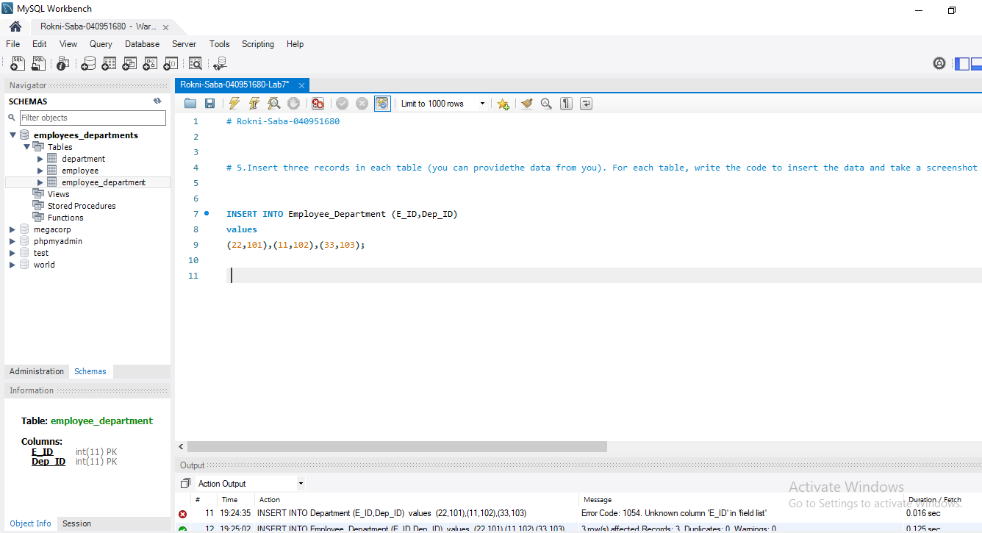

6.Write select queries to show each table (separately) with the all data it has. Take a three screenshots, in each screenshot show the query with the resulted table that has the data.

6.1>>

**select * from employee;**

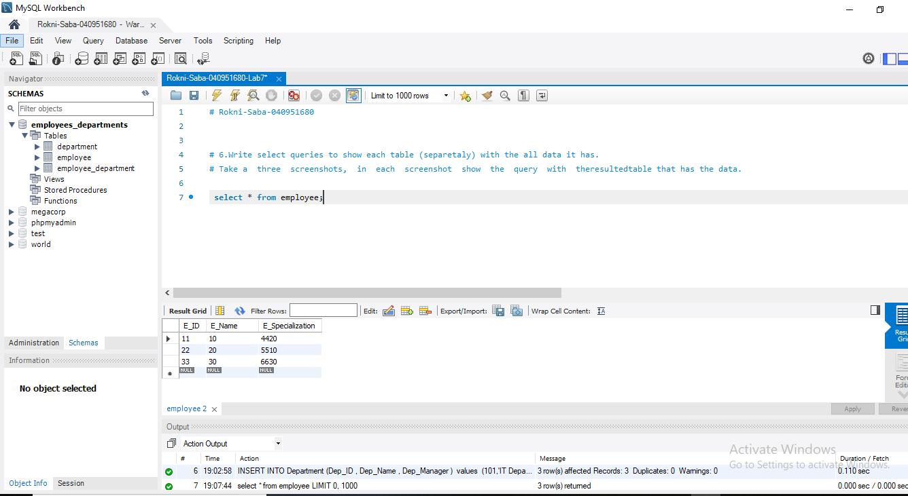

6.2>>

**select * from department;**

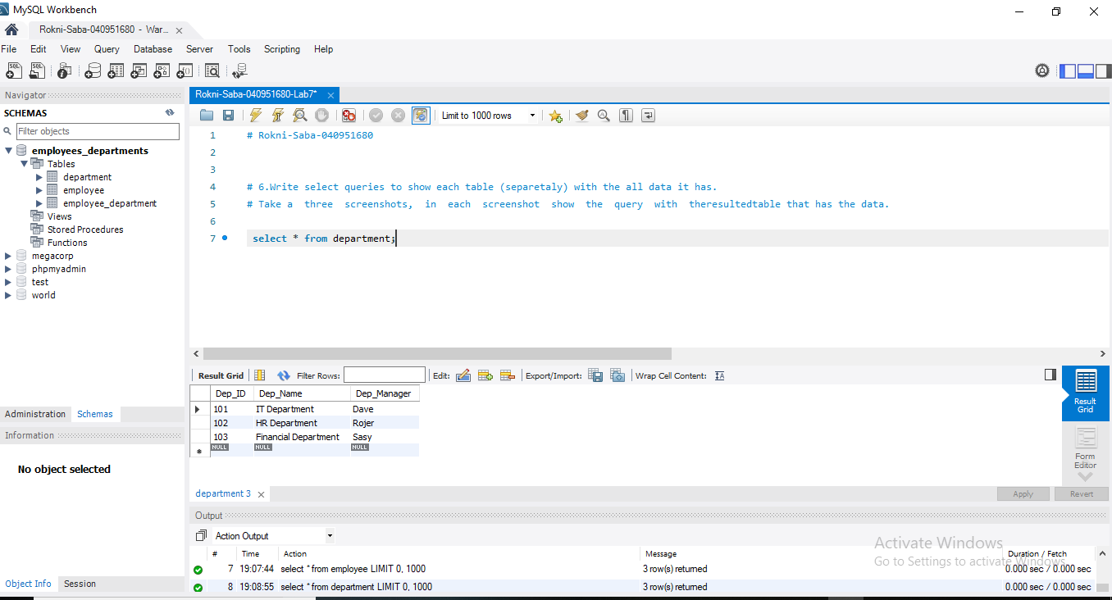

6.3 >>

**select * from employee_department;**

